**OSMEÑA BRANCH**

checking if **fpubid** has “x” and **fcompanyid** has not

POS_SALE

POS_SALE_PRODUCT

checking if **fpubid** has not “x” and **fcompanyid** has

POS_SALE

POS_SALE_PRODUCT

**UPTOWN BRANCH**

checking if **fpubid** has “x” and **fcompanyid** has not

POS_SALE

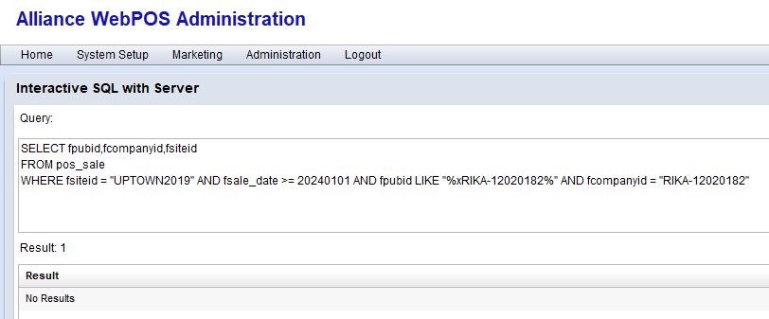

POS_SALE_PRODUCT

checking if **fpubid** has not “x” and **fcompanyid** has

POS_SALE

POS_SALE_PRODUCT

